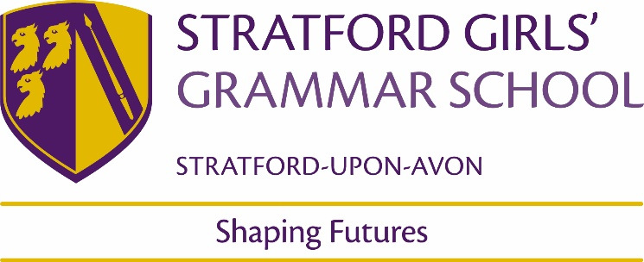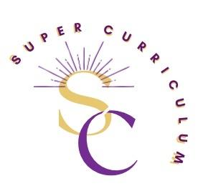

Food and Nutrition Department
Super Curriculum
Reading
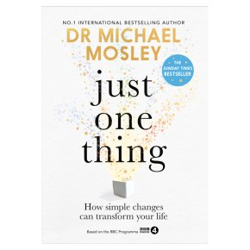  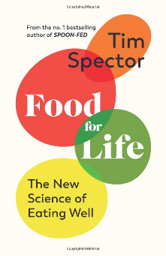  These are written by a Scientist and a Doctor – with a new look on food we eat. Michael Moseley looks at all aspects of health not just food. | Any cookbook from any of the many cooks/chefs – browsing a recipe book is great for inspiration which you can’t necessarily get from ‘googling’ when you know what you are looking for.  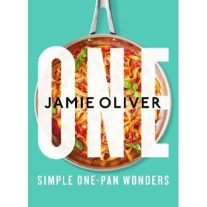  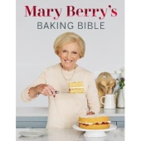  ISBN: 9781785947636  ISBN: 9780241431108  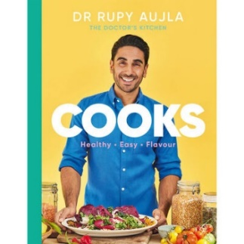  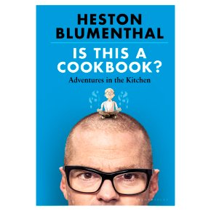  ISBN: 9781526621504  ISBN: 9781529148831
Films
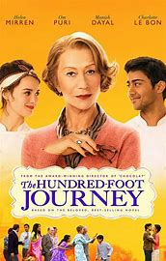

Toast (2010)
Nigel Slater is one of our all-time food icons, Based in Wolverhampton in the 1960s, it’s a wonderfully British story brought to life by director S.J Clarkson bursting with nostalgic food and flavours. It tells the story of how the acclaimed chef’s simple childhood favourites from his mother – who died when he was a young boy – shaped his relationship with cooking. Humorous in places, bittersweet in others, it’s always humbly obsessed with food.

The Hundred-Foot Journey (2014)
American comedy-drama film adapted from Richard C. Morais' 2010 novel of the same name. It is about a battle in a French village between two restaurants that are directly across the street from each other: a new Indian restaurant owned by an Indian immigrant family and an established French restaurant with a Michelin star owned by a French woman.

Supersize Me (2004)
This grotesque look at the fast food industry was a low-fi, high-impact production by American filmmaker Morgan Spurlock. Showing true dedication to his art, Spurlock ate nothing but McDonalds for 30 days and documented his stomach-turning experience. Shocking, funny, memorable and game-changing.

Podcasts
BBC World Service - The Food Chain - Downloads -The Food Chain examines the business, science and cultural significance of food, and what it takes to put food on your plate.  » podcasts (deliciouslyella.com) Wellness with Ella - Health and wellbeing, weekly podcast, recipes | BBC Radio 4 - The Food Programme - Downloads Investigating every aspect of the food we eat  Podcasts - BBC Good Food
Radio | Television
BBC Radio 4 - The Food Programme Investigating every aspect of the food we eat | There are many cookery shows which are good for learning new skills; for inspiration for recipes and for getting presentation ideas. E.g  Masterchef (both amateur and professional)  Great British Menu  Many chefs/cooks travel around this country and the world tasting and cooking the cuisine.  BBC Two - Inside the Factory some really good insights into food production along with history of foods and some science.  BBC Two - Back in Time for Dinner – food through the decades seen through eyes of a family  BBC One - Eat Well for Less? How different families can be helped to eat more healthily and for less money
On-line opportunities
On-demand webinars - British Nutrition Foundation a series of webinars from the British Nutrition foundation e.g nutrition and oral health
Healthy and sustainable diets - British Nutrition Foundation healthy and sustainable diets
News - British Nutrition Foundation latest food news
14 - 16 Years - Food A Fact Of Life a good site for recipes and reading on a variety of food issues as well as links to videos on skills.
Resources | IFST food science resource

Places to visit – maybe if you are on holiday you might come across one of these
Cadbury World: Enjoy The Cadbury World Experience – Bourneville

Blog - York's Chocolate Story (yorkschocolatestory.com) York

Visit The UK's Only Food Museum For A Great Day Out Suffolk

Traditional Tudor Cooking at The Weald & Downland Museum (wealddown.co.uk) Sussex see historical cookery and kitchens

If you are lucky enough to go on holiday look out for local markets and take in the different produce available – taste new ingredients.

