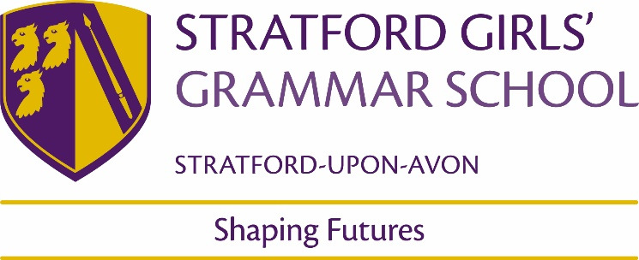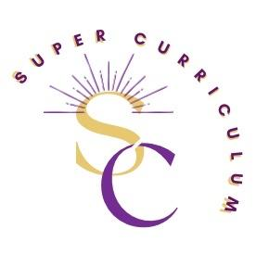
Maths Department Super Curriculum
Reading (books and journals)
Ian Stewart books Category:Books by Ian Stewart (mathematician) - Wikipedia
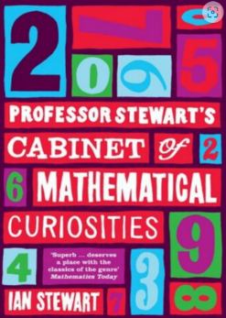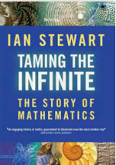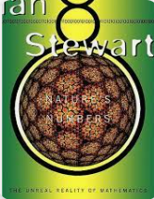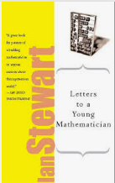
From biographies to world-changing ideas, Ian Stewart books explore all avenues of maths.
Other Books
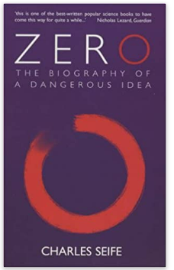  Charles Seife follows this fascinating number from its birth to the present day and explores the threat it poses to modern day physics. | 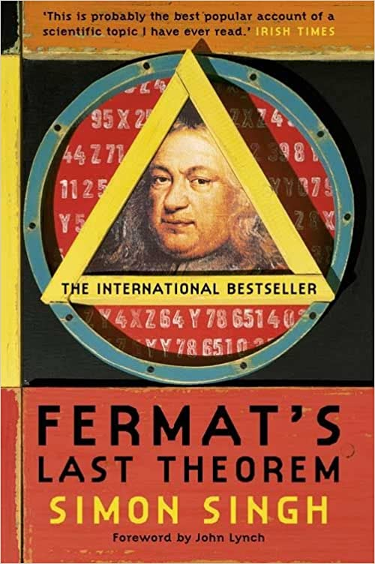  In this book, Singh tells a remarkable tale of intellect, determination and rivalry involving the people who became obsessed with solving Fermat’s Last Theroem |  | 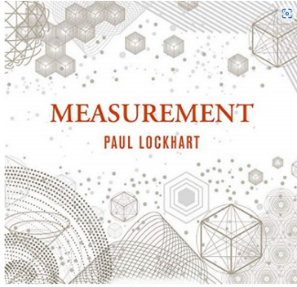  “What makes a mathematician is not just technical skill but a tenacious curiosity and desire for answers.” Measurement offers a new perspective of maths, introductions it as an artful way of thinking. |  | 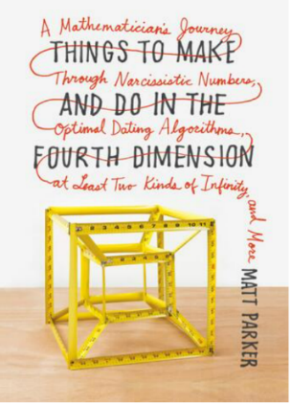  In his book, Matt Parker uses bizarre examples along with fascinating ideas of mathematics to shed light in maths in the modern world.
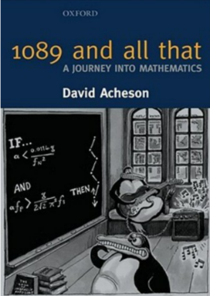  Acheson takes you on a journey of maths, from simple beginnings to deep mathematical ideas. Carefully crafted chapters each packed with puzzles ensure that no one gets lost on the journey. | 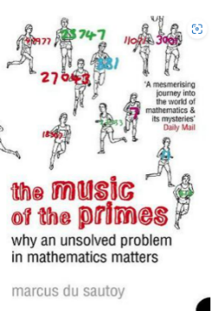  Reimanns hypothesis about the distribution of primes is still unsolven to this day. Du Sautoy takes you through history as mathematicians tried to solve this problem.
Magazines
Plus Maths
An online magazine which aims to introduce readers to the beauty and the practical applications of mathematics.

Films
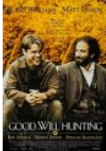  Will Hunting, a janitor in MIT, has a gift for mathematics, but needs help from a psychologist to find direction in his life. |  | The story of three brilliant African American women at NASA who turned around the space race and inspired the world. |  | 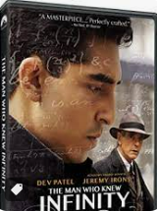  The life and career, of Ramanujan, an exceptionally gifted young mathematician, and his friendship with his mentor, Professor G.H. Hardy. |  | 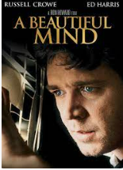  The real-life story of a mathematician and Nobel Prize winner, John Nash. Alongside his long-term battle with schizophrenia.
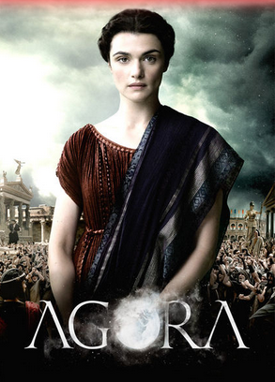  A story about Hypatia, a mathematician, philosopher and astronomer in the 4th century, and the relationship between religion and science. |  | 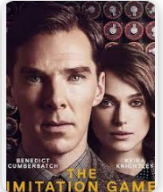  The real life story about mathemetician Alan Turing, and his attempts to crack the German Enigma code during World War II. |  | 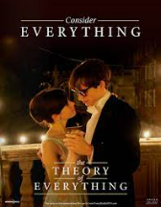  The real life story of the brilliant physicist Stephen Hawking and his wife Jane Wilde, as together they defy all odds by breaking new ground in the fields of medicine and science. |  | 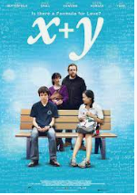  The real life story of a young autistic maths prodigy, Nathan, and the journey he embarks on when he is chosen to represent the UK at the International Mathematical Olympiad.
7-year old maths prodigy Mary, raised by her uncle, becomes the subject of a custody battle between her uncle and grandmother.

Podcasts/online lectures
Numberphile  Numberphile is an educational YouTube channel featuring videos that explore assorted topics from a variety of fields of mathematics. | Simon Singh Five numbers  A BBC radio mathematics adventure, where Simon Singh takes a quirky look at five of the most important numbers in mathematics: zero, pi, the golden ratio, the imaginary number i, and infinity.
Rob Eastaway - Home  Rob Eastaway has written several fun books and podcasts on maths, from explaining the hidden mathematics of everyday life to solving mind-bending puzzles! | https://simonsingh.net/  A website which includes a series of lectures, a blog and much more from the brilliant mind of Simon Singh.
Home - Hannah Fry  Hannah Fry is the host of multiple award-winning shows and podcasts. Her website provides you with just that, as well as academic research, her books, and some fascinating articles. | Maths on the Move  The podcast from plus.maths.org, will bring you the latest news from the world of maths, plus interviews and discussions with leading mathematicians and scientists about the maths that is changing our lives.
Mathematics | Gresham College  The College provides free lectures on all aspects of mathematics and its application in today's world. | Math Mutation  Maths Mutation is a podcast and blog which explores the fun, interesting and sometimes weird corners of maths that you will not learn about in school.
MOOCs and on-line opportunities
Oxford Online Maths Club  The Oxford Online Maths Club is a weekly livestream from the University of Oxford with maths problems, puzzles, mini-lectures, and Q&A. | Tom Rocks Maths  Tom is a Mathematician at the University of Oxford where he holds the position of Early Career Teaching and Outreach Fellow at St Edmund Hall
Awards and competitions
Maths Challenge (Junior, Intermediate and Senior) | Team Maths Challenge (Team of 4 – Year 8 and 9)
Teddy Rocks Maths Essay Competition
An essay competition in which secondary school students are simply asked to explain their favourite mathematical topic in an essay aimed at a non-specialist audience.
Places to visit
Bletchley Park | Home  Bletchley Park was the British governments cryptology establishment during the World War 2. It was where Alan Turing and other agents decoded the enemy’s messages using the Enigma machine. | Winton Gallery - Mathematics  This though provoking gallery highlights the importance of mathematicians and their ideas and how this has played a vital role in building the world we live in.
Newton's House  Visit the house associated with Isaac Newton, the famous Apple tree, and gravity. | Maths City  An interactive space to explore the wonders of mathematics and its importance and influence in the modern world.
Membership and affiliations

