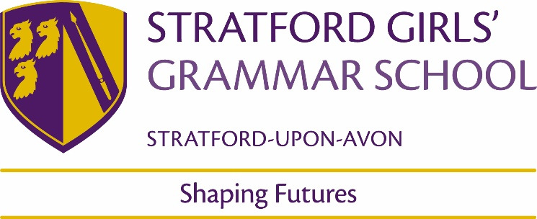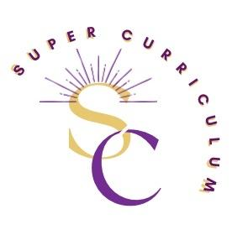

KS4 History Department
Super Curriculum
Reading (books and journals)
Title by Authors Name
- Ten days that shook the world – John Reed. An eyewitness account of the revolution  - Memoirs of a revolutionary – Victor Serge. A memoir covering the Revolution and Stalin’s control over Russia  - The White Guard – Mikhail Bulgakov. A classic Russian account  - Sashenka – Simon Sebag Montefiore. A novel written by a fine historian of Russian History  - Darkness at Noon – Arthur Koestler. Short and exciting covering the revolution and the Stalinist period in Russia  - Lenin for Beginners – Richard Appignanessi (Comic book) want to know the ins and outs of Lenin’s thought with some History thrown in? this is the place to start  - Petrograd – Philip Gelatt and Tyler Crook (Graphic Novel) Rasputin and his death read a fictional account, quite gruesome  - A day in the life of Ivan Denisovich – Alexander Solsyhenitsyn. A novel covering the Gulags  - Death of Stalin – Armando Iannucci (graphic Novel and satire) book and film (15)  - Envy – Yuri Olesha. A funny satire on Soviet society | - 1984 by George Orwell  - The Cold War by John Lewis Gaddis  - When the wind blows by Raymond Briggs  - The secret state: preparing for the worst 1945-2010 by Peter Hennessey  - The spy who came in from the cold by John Le Carre  - The book of Daniel by E.L.Doctorow  - Our man in Havana by Graham Greene  - Watchmen by Alan Moore and Dave Gibbons  - Cat’s cradle by Kurt Vonnegut  - Post War: A history of Europe by Tony Judt  - The innocent by Ian McEwan  - Stasiland by Anna Funder  - Black Sun by Owen Matthews  - The coldest winter / The coldest city by Anthony Johnston
- A short history of medicine – Steve Parker
- Blood and Guts: A short history of medicine by Roy Porter – Overview of unit
- Time traveller’s guide to Medieval England by Ian Mortimer – Insight into Medieval Medicine
- Blood and Guts: A History of Surgery by Richard Hollingham – Developments in surgery
- The Knife Man: Blood, Body-snatching and the Birth of Modern Surgery by Wendy Moore - Developments in surgery
- The Greatest benefit to mankind by Roy Porter – Overview of the unit
- The Butchering Art by Lindsey Fitzharris -Joseph Lister and Antiseptic
- William Bynum, A Very Short Introduction to the History of Medicine (‘A Very Short Introduction to..’ series)
- Medicine: A graphic History by Phillipe Bercovici and Jean-Noel Fabiani

Podcasts / Films
- Doctor Zhivago – a 1960’s classic, beautifully filmed and acted.  - Reds – A love story based on the Russian Revolution and John Reed’s written account (see above)  - Battleship Potemkin / Ten days that shook the world – Classics from Eienstein produced during the Soviet era silent movies that can be seen on Youtube  - A young Doctor’s notebook – Daniel Radcliffe and John Hamm provide excellent acting in a dark comedy series based on Bulgakov’s (see above) short stories of the same name. Series one is set during the Russian Revolution and series two during the Russian civil war.  - A history of the Russian Revolution in colour | - Versus History features History teachers debating historical arguments. It’s aimed at A Level as well as GCSE, so stretch yourself! There are episodes on all sorts of topics, the easiest way to browse is to press ‘Control F’ and search key words on this page http://www.versushistory.com/podcasts.html  - History Rocks: Short 15 minute podcasts on the Cold War. A Level focused but still great to challenge yourself and build-up in-depth knowledge. https://historyrocks.co.uk/podcasts/  - GCSE History Revision Podcast (has an image of Nixon looking grumpy: scroll through their back catalogue for Cold War and Germany. https://open.spotify.com/show/05QCvZNx0liWItoVjycQsD  - Dan Snow’s History Hit: Browse back catalogue for Cold War and range of topics. https://www.historyhit.com/podcasts/
- Sawbones: various topics about medical history, in-depth knowledge but very accessible and genuinely funny! Scroll through their back catalogue and find their earlier episodes which cover topics we cover: cholera, plague, four humours, antibiotics.  - https://open.spotify.com/show/4Zkj8TTa7XAZYI6aFetlec A useful collection of podcast that cover a range of topics. | - ‘CNN Cold War’ YouTube – 24 part in-depth documentary series covering the Cold War. Could be especially useful to watch an episode on any event you are not confident on.  - The World at War: iconic series on WW2. Episode 24 and Episode 25 are very relevant to your course, look on YouTube.  - Busting the Berlin Wall: Amazing Escape Stories. All of the below are films watch out for age range  - Dr Strangelove  - Tinker, Tailor, Soldier, spy  - Bridge of spies  - Good night and good luck  - Top Gun  - JFK  - Thirteen days  - The fog of war
MOOCs and on-line opportunities
- Blood and Guts, a History of Surgery https://www.bbc.co.uk/programmes/b00d4b70/episodes/guide  - Pus, pain and poison documentary https://www.bbc.co.uk/programmes/p01f51s5  - Scream! A History of anaesthetics http://www.histansoc.org.uk/scream---history-of-anaesthesia.html  - *Filthy cities Medieval London: Dan Snow https://www.dailymotion.com/video/xydz4g  - Breaking the Mould, telling the story of penicillin (BBC) https://www.bbc.co.uk/programmes/b00ly0t1  - Quacks (Youtube)  - Florence Nightingale https://www.youtube.com/watch?v=jONlz7vaMnU&t=41s  - Edward Jenner https://www.youtube.com/watch?v=sJRJeOxX6no&t=8s  - John Hunter- Links to background knowledge for Jekyll and Hyde for English GCSE. https://www.youtube.com/watch?v=BT14Xzqvfoo | Cold War | National Army Museum (nam.ac.uk)  Cold War - Victoria and Albert Museum (vam.ac.uk)  National Cold War Exhibition | Things to see and do | Cosford | RAF Museum
Awards and competitions
Places to visit
https://museumcrush.org/britains-best-places-to-see-medical-collections-and-museums/ | Imperial War Museum  Bentwaters Cold War Museum  Hack Green Nuclear bunker  RAF Museum Cosford
Membership and affiliations
Historical Association | https://www.history.org.uk/

