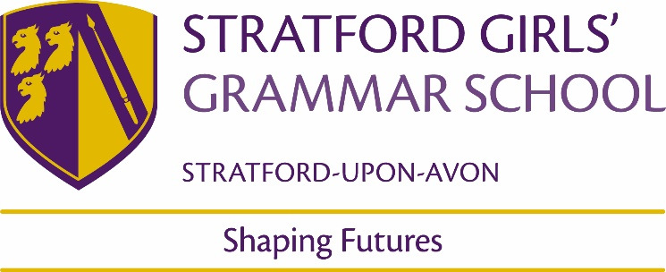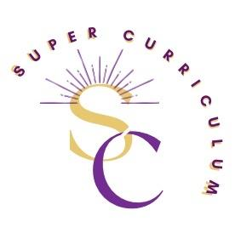

Geography Department
Super Curriculum
Reading (books and journals)
Author | Title
Hans Rosling | Factfulness
Tim Marshall | Prisoners of Geography, Power of Geography, the future of Geography, Divided, Prisoners of Geography: Our World Explained in 12 Simple Maps (KS3)
Mike Berners-Lee | There is no planet B
Gaia Vince | Adventures in the Anthropocene.
Danny Dorling | Population 10 billion
Fred Pearce | When rivers run dry
Martin Dorey | No more plastic
Caroline Criado-Perez | Invisible women
Alistair Bonnet) | Unruly Places
Tom Miller | China’s Asian Dream
Bill Bryson) | Notes from a Small Island
Anita Ganeri | Horrible Geography
Elizabeth Laird | The Garbage King (KS3)
Miriam Halahmy | Hidden (KS3)
James Doyle | Where on Earth? Without the boring bits (KS3)
Petty & Maizels | The Amazing Pop-up Geography Book (KS3)
Alexandra Stewart | Everest: The remarkable story of Edmund Hillary and Tenzing Norgay (KS3)
Podcasts
Costing the Earth - BBC Radio 4 - Costing the Earth - Available now | The Inquiry - BBC World Service - The Inquiry - Downloads
Royal Geographical Society – “Ask the Geographer podcasts” - https://www.rgs.org/schools/teaching-resources/ask-the-expert-podcasts/ | Podcasts from Oxford University School of Geography and the Environment – School of Geography and the Environment Podcasts | University of Oxford Podcasts
The Documentary podcast - BBC World Service - The Documentary Podcast - Downloads | Talks from the Royal Geographical Society - Royal Geographical Society - Royal Geographical Society (with IBG) (rgs.org)
MOOCs and on-line opportunities
THE CONVERSATION.COM The Conversation: In-depth analysis, research, news and ideas from leading academics and researchers. | The Royal Geographical Online Lectures - Royal Geographical Society - Resources for schools (rgs.org)
The Financial Times | The Open University - https://www.open.edu/openlearn/free-courses/full-catalogue
New Scientist - https://www.newscientist.com/ | The Economist  https://www.economist.com/
BBC News https://www.bbc.co.uk/news | Future Learn – https://www.futurelearn.com/
Open Yale Courses -https://oyc.yale.edu/ | UN CC: e-Learn - One UN Climate Change Learning Partnership (unccelearn.org)
Ivy League Online Courses - https://www.classcentral.com/collection/ivy-league-moocs | Geography of World Cultures – Stanford University -  https://www.openculture.com/2007/05/five_stanford_c.html#google_vignette
British Geological Survey - https://www.bgs.ac.uk/ | Populations past https://www.populationspast.org/imr/1861/#6/54.457/-5.131/bartholomew
Gresham College Lectures - https://www.gresham.ac.uk/schools-and-colleges/geography-and-environment | Green Careers - https://www.stem.org.uk/resources/collection/515477/green-careers-videos
Awards and competitions
UK Polar network – Flag competition | The Royal Geographical Society’s: Young Geographer of the Year Competition
Places to visit
Location | Geography to see…
Jurassic Coast/Holderness coast/ Llandudno | Sea defences, rocks and fossils.
Eden project/Living rainforest/Birmingham Botanical Gardens/Stratford Butterfly farm. | Biosphere/Biomes
Lapworth Museum of Geology/Natural History Museum | Lithosphere and Natural Hazards
Lake District/Snowdonia National Park/Peak District | Glaciation
Sea life Centre | Sustainability and conservation
Stratford Olympic Park | Regeneration
Membership and affiliations
Royal Geographical Society https://www.rgs.org/ | Geographical Association  https://geography.org.uk/
Documentaries & Films
Into the Inferno | Rotten
The Boy who harnessed the wind: | Africa
Cowspiracy | Our planet
Planet Earth and Planet Earth 2 | Blue Planet
Before the Flood (2016) | Slumdog Millionaire (15)
An Inconvenient Truth and An Inconvenient Sequel (2006, 2016) | Hotel Rwanda (12)
The Impossible (2012): | The Americas with Simon Reeve
Simon Reeve around the world | Mediterranean with Simon Reeve
Britain Underwater: Fighting the Floods
