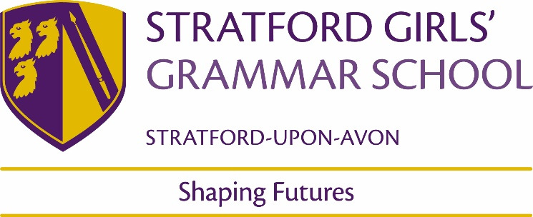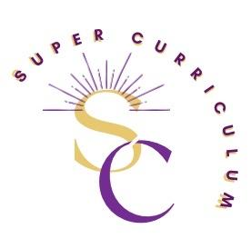

Religious Studies Department
Super Curriculum
Reading (books and journals)
Title by Authors Name
A Little History of Religion by Richard Holloway | Easy to read. Follows the development of Religion(s) chronologically. Great at putting religions into context.
The Philosopher Queens by Rebecca Buxton & Lisa Whiting | Excellent book with chapters on lesser-known female philosophers through the ages, each written by a contemporary female philosopher
How the World Thinks by Julian Baggini | A global overview of Philosophy in the world
Sophie’s World by Jostein Gaarder | Novel written for teenagers; a great introduction to Philosophy
The God Delusion by Richard Dawkins | 2006 book by British evolutionary biologist, Richard Dawkins. One of the most well-known critiques of religion. We recommend you follow it up with The Dawkins Delusion by Alister McGrath (copy in the school library)
Plato’s Republic by Angie Hobbs (A Ladybird Expert Book) | An excellent and simple introduction to one of the greatest philosophical works by a professor of Philosophy who has spoken at our school
The Philosopher’s Daughters by Peter Vardy | Peter Vardy, one of the world’s most respected theologian-philosophers, answers 54 profound questions about life asked by his young daughters in this unique and thought-provoking book. If you like this, try his Puzzle of God/ Ethics/ Christianity books.
A Very Short Introduction series | These books are excellent; written by experts in their fields, they cover a range of topics, including Theology, Islam, Sikhism etc. A great way into a topic.
There are so many books the RS department could recommend. If you have a particular area of interest come and talk to us and we will make recommendations specific to your needs.
Podcasts
The RE Podcast (all key stages) | https://www.therepodcast.co.uk/  Excellent Podcast, very accessible and covers a wide range of topics and issues.
The Panpsycast Philosophy Podcast (key stages 4 & 5) | https://thepanpsycast.com/  Excellent podcast that includes the A-level specification and interviews with some of the biggest names in Philosophy
Beyond Belief (Radio 4) (all key stages) | https://www.bbc.co.uk/programmes/b006s6p6/episodes/player  Series exploring the place and nature of faith in today's world
In Our Time (Radio 4) (key Stage 4 & 5) | https://www.bbc.co.uk/programmes/b006qykl/episodes/downloads  A huge collection of podcasts on religion and philosophy with experts in their fields discussing big ideas.
MOOCs and on-line opportunities
University of Chester TRS Webinars  https://vimeo.com/channels/1613728/videos/page:2 | A series of webinars recorded by the Theology & Religion Department. Aimed at A-level students, but accessible and on a range of topics, including Buddhism, Theology, Philosophy and more
History of Ideas, BBC Radio 4  https://www.bbc.co.uk/programmes/b04bwydw | Short, animated b=video introductions to some of the most important ideas in History.
Films
Prince of Egypt | Animated version of the Exodus story
The Miracle Maker | Animated version of Life of Jesus
Joseph | Musical of the story of Joseph from Book of Genesis
Mary Magdalene | 2018 film about the Life of Jesus from the perspective of a female disciple
Awards and competitions
There are many competitions announced each year; below are just some examples. Ask Mrs Steele if you would like more information.
Spirited Arts | www.natre.org.uk
Bible Society | https://www.biblesociety.org.uk/
Sheffield Uni Philosophy Essay Competition | Philosophy Essay Competition 2023 | Philosophy | The University of Sheffield
Places to visit
Leamington Gurdwara | A very welcoming Sikh place of worship. You will be welcomed and fed!  See https://www.leamingtongurdwara.org/ for details.
Coventry Cathedral | Really important local place of worship.  See https://www.coventrycathedral.org.uk/ for visiting times etc.
Shree Krishna Mandir, Leamington | Hindu temple in Leamington. 12 Crown Terrace, Leamington Spa CV31 3AN. May be best to phone in advance.

