Drama Department
Super Curriculum
Key Stage 3
Feed your creativity!
https://padlet.com/fraters/drama-supercurriculum-key-stage-3-af3chc2w8j7s5wve

RSC Learning Zone  Shakespeare Learning Zone | Royal Shakespeare Company (rsc.org.uk) | Want to be a Shakespeare scholar?  You will find key facts, key scenes, pictures from past productions, videos of actors and directors working on and performing the plays AND find out about all the main characters and how they relate to each other.
BBC Learning Zone  The Curious Incident of the Dog in the Night-Time: Staging choices - Dramatisation - AQA - GCSE English Literature Revision - AQA - BBC Bitesize  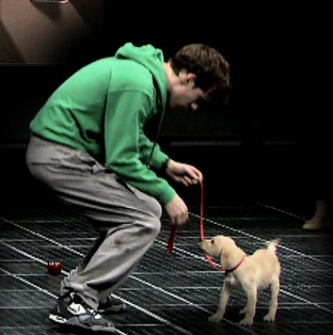 | Interested in how to stage a play?  The Learning Zone is a detailed resource looking in more depth at specific plays, for example ‘The Curious Incident of The Dog In The Night-Time. Useful when thinking about how you might approach a text in performance.
Drama Online  Drama Online - Home (dramaonlinelibrary.com) | Inspired by performance?  Access to a wide range of performances to extend and challenge your ideas about theatre.  Use this info to access the site
Podcasts
National Theatre podcasts  Talks, events & training | National Theatre | Want to look behind the scenes?  The National Theatre Podcast explores how theatre connects to the big issues of our time. You can go behind the scenes to investigate the artists and the ideas behind some of the most interesting, recent productions.
Awards and competitions
Performing Shakespeare competition – Years 7 and 8  Performing Shakespeare | ESU | Want to try out your performance skills?  A chance to explore your performance skills and have the opportunity to perform in front of an audience.
Model box competition for Year 7  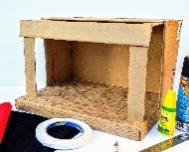 | Can you think like a designer?  A great opportunity to showcase your design skills and develop into the theatrical world of design by entering this design competition.
Costume Design challenge for Year 8 and 9 | Is costume design your thing?  Design and make a costume and enter this challenge in the summer term.
Places to visit
Local Theatres | Love Watching Performance?  There are a whole range of things on locally…  Warwick Arts Centre  RSC Stratford Upon Avon  Oxford Playhouse  Birmingham Hippodrome  Alexandra Theatre, Birmingham  Bear Pit Stratford Upon Avon  Play Box, Warwick
Other opportunities
RSC Shakespeare Workshops | Workshops with experienced practitioners, offering performance opportunities.
Visiting practitioners/speakers | Learn from the professionals  Come along to one of our lunchtime talks with visiting practitioners – look out for the messages in Teams
Masterclasses | Want to challenge yourself further?  Sign up for a masterclass led by student leaders. A great way to have fun and extend your skills!
Whole school show | Get involved!  Opportunities to act, assistant direct, all backstage and technical roles. Look out for the announcement on Teams
Tech theatre club for KS3 – led by students | Are you interested in tech?  Sign up for our technical theatre club in the Autumn term
Key Stage 4/5

Feed your creativity!

https://en-gb.padlet.com/fraters/drama-supercurrculum-key-stage-4-5-1jyd97aa29jhmg0

Digital Theatre  Home | Digital Theatre+ (digitaltheatreplus.com) | Love watching a wide range of performances?  Sign up for Digital Theatre + to access multiple productions and resources to extend your knowledge.  Invitations will be sent out in September
Drama Online Drama Online - Home (dramaonlinelibrary.com) | Access to a wide range of performances to extend and challenge your ideas about theatre.  Use this info to access the site
http://www.complicite.org/  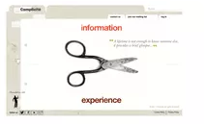 | Want to understand the devising process?  Complicite are a fascinating company who approach each show in a very unique way. Read about their process to inspire your approach to rehearsal and creating performance.
https://www.thepaperbirds.com/ | Are you politically minded?  The Paper Birds is a devising theatre company, with a social and political agenda. Thy are recognised as UK leaders in devised verbatim theatre.
https://www.geckotheatre.com/ | Interested in the creative process?  Gecko employ a diverse freelance team of devising performers, creatives, and technicians to work alongside the director to bring their own skills, background, experiences and culture into the creation of our work. A great company to get to know!
https://highlysprungperformance.co.uk/ | You need to know about this company!  They describe their work as:  BRAVE, BEAUTIFUL and EXTRAORDINARY  Using movement to tell stories when words won’t do.  A Coventry based group that create original physical theatre that empowers young people to explore and express their unique creativity and identity.
Podcasts
National Theatre podcasts  https://www.nationaltheatre.org.uk/learn-explore/talks/#podcasts | Want to look behind the scenes?  The National Theatre Podcast explores how theatre connects to the big issues of our time. You can go behind the scenes to investigate the artists and the ideas behind some of the most interesting, recent productions.
Places to Visit
Theatre  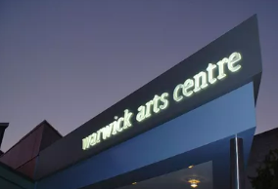 | Love Watching Performance?  There are a whole range of things on locally…  Warwick Arts Centre  RSC Stratford Upon Avon  Oxford Playhouse  Birmingham Hippodrome  Alexandra Theatre, Birmingham  Bear Pit Stratford Upon Avon  Play Box, Warwick  The above are suggestions locally to watch theatre.
Art Galleries, Museums, concerts, live events.  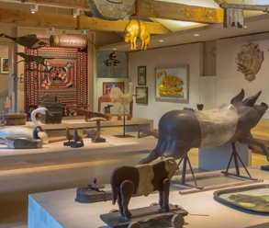 | Look up and Look out!  Take opportunities to visit places that offer exhibitions or performances in unexpected venues.  Within easy reach are…  Compton Verney  MAC Birmingham  Coventry Artspace  Pitt Rivers Oxford
Other Opportunities
Masterclasses | Want to challenge yourself further?  Sign up to lead a masterclass. A great way to have fun and test your skills! Ask your teacher for some information about how to do this
Visiting practitioners and speakers | Learn from the professionals  Come along to one of our lunchtime talks with visiting practitioners – look out for the messages in Teams
RSC Playmaking project – Year 12 only  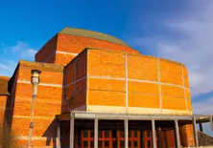 | Fancy performing at the RSC?  Sign up for this project in the summer term. Understanding how to work as part of a team to create a performance piece for one of the RSC stages is a great opportunity.
Whole school show | Get involved!  Opportunities to act, assistant direct, all backstage and technical roles. Look out for the announcement on Teams

