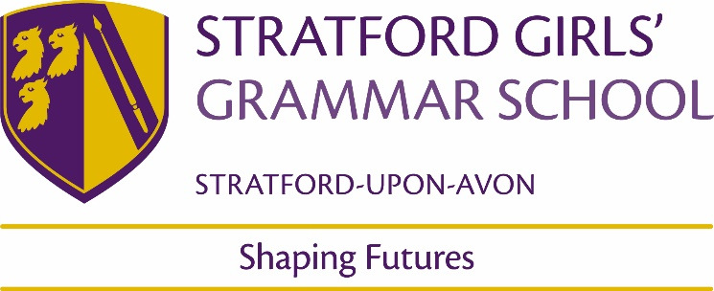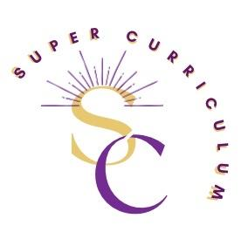

Physical Education Department
Super Curriculum
Reading (books and journals)
Books | Journals
Healthy Living for Teens- Al Desetta | The Effects of Exercise on the Body in Women- Bryner et.al (2017)  https://www.tandfonline.com/doi/abs/10.1080/07315724.1997.10718651  Article looking at the effects of exercise on body composition.
Young Champions Mind- Kim Afremow | Effects of Exercise on Sleep- Uchida et.al (2012)  https://www.frontiersin.org/articles/10.3389/fneur.2012.00048/full  This journal article looks at previous research regarding the effects of exercise on sleep quality in young adults and elders. Very beneficial for when we are looking at the benefits of exercise on the body.
Women Superstars- Kevin Pettman | Resilience and Wellbeing in Sport- Junnarker, Sahni and Gill (2021)  https://www.taylorfrancis.com/chapters/edit/10.1201/9781003057802-20/resilience-well-being-sports-mohita-junnarkar-sanjeev-sahni-shivjot-gill  Application of both resilience and wellbeing in a sports setting and the impact on sports performance.
The Complete Guide to Sports Nutrition- Anita Bean
Women in Sport- Rachel Ognotofsky
Ready Steady Mo- Mo Farah
Podcasts
TEDTalk-  https://youtu.be/3dqXHHCc5lA  Professor of Clinical Psychology, highlights the appalling rise of mental illnesses in the past decades and that nutrition is playing a larger role in this than we think. This talk compels us to accept the undeniable relationship between dietary patterns and mental health to reinforce just how much nutrition matters. | Let’s Be Real- Sammy Jaye  https://podcasts.apple.com/gb/podcast/lets-be-real-with-sammy-jaye/id1494175847  Let’s Be Real, hosted by Sammy Jaye, is all about having powerful and candid conversations with activists, athletes and influencers, while discussing real-life issues – from mental health and political activism to diet and nutrition.
Fit, Healthy and Happy Podcast  https://open.spotify.com/show/7doKHsQSUqD6T9mkYO33KY  The Fit, Healthy and Happy podcast brings you the best fitness education straight from the best fitness coaches and trainers around. They will break down and explore popular fitness topics such as weight loss, motivation, muscle increase and habits that lead to long term fitness success. | Goals4Girls- The Game Changers  https://podcasts.apple.com/gb/podcast/the-game-changers/id1464596772  In this award-winning podcast Sue Anstiss talks to trailblazers in women sport. These are the individuals who are knocking down barriers and challenging the status quo for women and girls everywhere.
The Sport Psych Show- Dan Abrahams
https://podcasts.apple.com/gb/podcast/231-danielle-cormier-dr-kent-kowalski-self-compassion/id1434313037?i=1000606010905
This episode looks at the importance of self-compassion in athletes. This would be particularly useful for all team players and elite sports performers in the school.
MOOCs and on-line opportunities
Sports and Society- My MOOC  https://www.my-mooc.com/en/mooc/sports-and-society/  This course draws on the tools of anthropology, sociology, history, and other disciplines to give new perspectives on the games we watch and play. | The Science of Endurance Training- My MOOC  https://www.my-mooc.com/en/mooc/endurance-performance/  Endurance sports such as cycling, marathons and triathlons are increasingly popular. Events attract everyone from elite athletes striving for performance improvements, to sedentary individuals looking to improve their health and well-being. This course will helps individuals train for and improve their performance in endurance sports.
Sport for Sustainable Development- My MOOC  https://www.my-mooc.com/en/mooc/sport-for-sustainable-development/  Discover how sports can aid the sustainable development agenda in this free online development course from The International Platform on Sport and Development. | Nutrition, Exercise and Sport  https://www.my-mooc.com/en/mooc/nutrition-exercise-and-sports/  This course looks specifically of the nutritional strategies that can be used to develop athletic performance.
Awards and competitions
Local and National Sports Fixtures and Tournaments-  These tournaments and local fixtures are for U12 to U18 teams. | South Warwickshire Championships-  The championships are for all secondary students representing their school in their chosen sports. Y7 to y13.
External links to clubs such as Stratford Rowing Club and Thunderbirds Netball Club-  We have set up excellent links with local clubs so students are able to pursue their sporting talents and passions outside of school. The opportunities this provides for our students is outstanding and we have benefited from the success they have had a club level in our school teams. | ESAA Schools Cup  Students represent the school in a combined event.
Warwickshire County Championships
SGGS has qualified on a number of occasions to represent the area at the County Championships. This has allowed our students to participate in strong competitions against other schools representing their area.
Places to visit
Warwick University- Labs and Fitness centre | Stratford Rowing Club
Sports Tour | Condover Hall
Membership and affiliations

