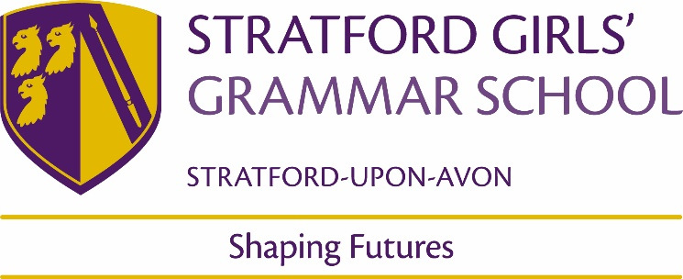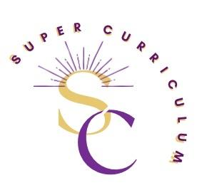

……English Department
Super Curriculum
Reading (books and journals)
Title by Authors Name
English Review  The Guardian/The Observer Cultural Pages  Times Literary Supplement  English Media Centre Magazine  New York Literary Review | https://www.theguardian.com/uk/culture  https://www.the-tls.co.uk/  https://www.englishandmedia.co.uk/e-magazine  https://literaryreview.co.uk/subject/new-york
Podcasts
BBC Radio 4 In Our Time  BBC Radio 4 Word of Mouth  BBC Radio 4 Front Row  BBC Radio 4 The Moral Maze  BBC Radio 4 – This Cultural Life | https://www.bbc.co.uk/programmes/b006qykl/episodes/downloads  https://www.bbc.co.uk/programmes/b006qtnz/episodes/downloads  https://www.bbc.co.uk/programmes/b006qsq5/episodes/downloads  https://www.bbc.co.uk/programmes/b006qk11/episodes/downloads  https://www.bbc.co.uk/programmes/m0010fl4/episodes/downloads
Simon Schama – History of Now/ The Romantics BBC iPlayer | https://www.bbc.co.uk/programmes/m000mfnj  https://www.bbc.co.uk/programmes/p0d5wch4
The Open University – free Online Courses in Poetry/Drama/Prose  Plays in performance/Lectures/ Poetry analysis | https://www.open.edu/openlearn/free-courses/full-catalogue  https://www.digitaltheatreplus.com/
MOOCs and on-line opportunities
https://podcasts.ox.ac.uk/series/approaching-shakespeare | Approaching Shakespeare Course; Dr Emma Smith; Oxford University
https://keats-shelley.org/ | Keats podcasts
Imperial War– WWI poetry – articles and resources  https://www.bl.uk/learning/online-resources  https://www.rsc.org.uk/learn/schools-and-teachers/teacher-resources | Wide range of articles on genres and periods from Medieval to Modern  RSC education resources- all plays and sonnets
Awards and competitions
Felix Dennis Poetry Competition | https://www.stratfordliteraryfestival.co.uk/competitions/felix-dennis-young-poets-competition
The Poetry Society Competition | https://poetrysociety.org.uk/tag/national-poetry-competition/
EMC Close Extract Analysis Competition  Oxford University English Essay Competition  Keats Society Essay Writing Competition  Other competitions as advertised annually | https://www.englishandmedia.co.uk/competitions/emagazine-close-reading-competition-2023-now-closed  https://www.ox.ac.uk/admissions/undergraduate/applying-to-oxford/teachers/academic-competitions-schools-and-colleges  https://keats-shelley.org/prizes/keats_shelley_prize_2023
Places to visit
Theatres | The Globe; The RSC; The National Theatre; Soho Place – any local or regional theatre!
Membership and affiliations
English Media Centre
RSC – Stratford
The English Review

