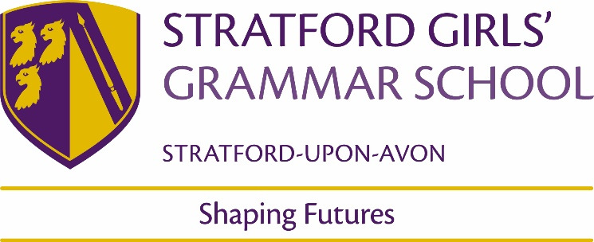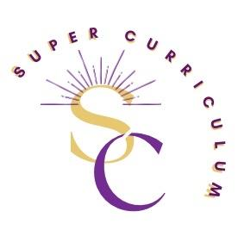

Music Department
Super Curriculum
Reading (books and journals)
Title by Authors Name | Tim Carter: The Marriage of Figaro
 | Charles Osborne: The Complete Operas of Mozart
 | Mary Hunter: Mozart’s Operas: A Companion
Podcasts
Gresham College Video Resources | https://www.gresham.ac.uk/watch-now/browse-all?type=577
Online Jazz Analysis “Lessons” | https://www.jazzadvice.com/
Music Ted Talks | https://www.ted.com/playlists?topics[]=music
MOOCs and on-line opportunities
Moocs/Music-arts | https://www.edx.org/learn/music-arts  https://www.edx.org/search?q=music&tab=course
AoS1  Online documentaries – Mozart (BBC) | https://www.youtube.com/watch?v=6DDxxsRZ6_0  Mozart Documentary -The Genius of Mozart Miracle of Nature
AoS1  Purcell | https://www.youtube.com/watch?v=Fr6AXKibLw8  Purcell – The Londoner
AoS1  Royal Opera House education resources | https://www.roh.org.uk/schools/resource/the-marriage-of-figaro-act-1
Inside the Score | https://www.youtube.com/@InsidetheScore
BBC Great Composers – Bach | https://www.youtube.com/watch?v=FGQce4ZH75k
Online documentary – Swing Music | https://www.youtube.com/watch?v=Anob9IMBE70  The Swing Thing
Louis Armstrong Documentary | https://www.youtube.com/watch?v=WPspHmFoEYs
Sondheim Documentaries | https://www.youtube.com/watch?v=-73ZRDqYNHU  The World of Stephen Sondheim  https://www.youtube.com/watch?v=HDEAYJcenI8  Why Sondheim’s music is so addictive
Jason Robert Brown Composition Masterclass | https://www.youtube.com/watch?v=oXyyhKHyEzo&t=954s  A songwriting masterclass
Sondheim Masterclasses | https://www.youtube.com/watch?v=aR80qiXgMuQ  https://www.youtube.com/watch?v=PT7GC9oJ9xY  https://www.youtube.com/watch?v=DBCVaFqGJwg&t=72s  https://www.youtube.com/watch?v=2PVwQQ_U30I
Claude-Michel Schonberg Interview on Les Miserables | https://www.youtube.com/watch?v=6JYUbxiB-wc
Kurt Weill Documentary Short | https://www.youtube.com/watch?v=b6hcXOX3nbA  The music of Kurt Weill
Howard Goodall: The Story of Music in 6 parts | https://www.youtube.com/watch?v=I0Y6NPahlDE  https://www.youtube.com/watch?v=qMxsE8wawVA  https://www.youtube.com/watch?v=gPi_PWGSCaw  https://www.youtube.com/watch?v=MvzXcxyyhc0  https://www.youtube.com/watch?v=UxzvVGlVZqE  https://www.youtube.com/watch?v=uxmzqDmL2ps
Howard Goodall: Big Bangs | https://www.youtube.com/watch?v=Sl8PpGukzCE  https://www.youtube.com/watch?v=n0GNXkgRlVY  https://www.youtube.com/watch?v=_ACwTMIj2nA  https://www.youtube.com/watch?v=Y9LrzyjzQ5o  https://www.youtube.com/watch?v=kAGK26bcLf0
Awards and competitions
 | House Music Competition (years 7 to 10)
 | Chamber Choir Annual Competition (held in Dudley, Worcester, Milton Keynes, etc) https://dudleyfestival.co.uk/
BBC Young Composer (biannually) | https://www.bbc.co.uk/programmes/articles/4mY3MbSJ5G2LvSbzZPbc85G/bbc-young-composer
Places to visit
Young Composer Workshops | https://www.bcmg.org.uk/event/bcmg-young-composers-summer2
B:Music – at Birmingham Symphony Hall free concerts | https://bmusic.co.uk/whats-on/category/free
Warwick Arts Centre – free concerts, workshops, open mic & courses. | https://www.warwickartscentre.co.uk/whats-on/#event_price_and_offers=82&search=&date_from=&pp=12&p=1
Stratford Playhouse | https://www.stratfordplay.co.uk/home56a7f312#PlayMusic
Membership and affiliations

