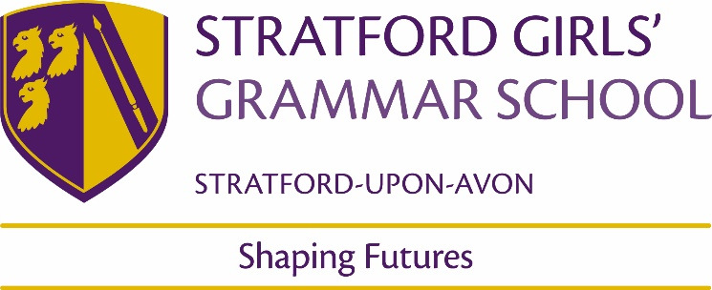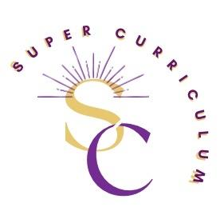

**English Department Super Curriculum**

Reading Tasks

Access a wide range of articles and journals from Romanticism to Chaucer to Marxism at [The British Library](https://www.bl.uk/)

Read [The English Review](https://www.hoddereducation.co.uk/subjects/english/products/16-18/english-review) (SGGS Library) – superb range of examination tailored essays and articles

Read [The English Media Centre Magazine](https://www.englishandmedia.co.uk/e-magazine) (EMC in SGGS Library) outstanding quarterly magazine packed with up to date articles on issues in English Language/Literature/Media

Access [Cambridge University English Undergraduate Reading List](https://www.kings.cam.ac.uk/study/undergraduate/reading-lists) to prepare and challenge your wider reading

Read [The Guardian](https://www.theguardian.com/uk) for high quality free journalism



Writing Tasks

Enter [Cambridge University English Essay Writing Competition](https://www.trin.cam.ac.uk/undergraduate/essay-prizes/english-literature/)

Enter [Felix Dennis Young Poets Competition Stratford Literary Festival](https://ypn.poetrysociety.org.uk/poetry-opportunities/felix-dennis-young-poets-competition/)

Enter [Foyle Young Poets Competition](https://poetrysociety.org.uk/competitions/foyle-young-poets-of-the-year-award/#:~:text=The%20Foyle%20Young%20Poets%20of%20the%20Year%20Award%20is%20one,org%20by%2031%20July%202023.)

Enter [BBC Young Reporter Competition](https://www.bbc.co.uk/teach/young-reporter/competition/zghcydm)

Write your own blog/Contact Local Newspapers to ask if they would accept submissions



Listening Tasks

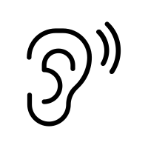

**TED talks**

Listen to a [TED talk](https://www.google.com/url?q=https%3A%2F%2Fwww.ted.com%2Ftopics%2Fliterature&sa=D&sntz=1&usg=AOvVaw3W-gfhU94zsAIkqwmnqZ_G) to develop your understanding of literature.

Listen to BBC [Radio 4](https://www.bbc.co.uk/sounds/play/live:bbc_radio_fourfm). Search for programmes: In Our Time; Start The Week; Poetry Please; Word of Mouth; The Moral Maze – excellent for contextualising literary texts and introducing high quality academic debate.

Listen to Oxford University [Professor Emma Smith Approaching Shakespeare Lectures](https://podcasts.ox.ac.uk/series/approaching-shakespeare) superb undergraduate level lectures on all plays

Watching Tasks



Watch a performance of **set drama texts and additional plays by a range of writers across time and genres** on [Digital Theatre +](https://www.google.com/url?q=https%3A%2F%2Fedu.digitaltheatreplus.com%2Fsearch%3Fq%3DAn%2BInspector%2BCalls&sa=D&sntz=1&usg=AOvVaw384qb-_X1XnyNcs1ayAsvG)

Massolit works with university academics to produce high-quality curriculum linked video lectures for GCSE and A- level students. [Massolit](https://www.massolit.io/). Look for materials on set texts/authors/genres

Watch video extracts/acting/director workshops on the [RSCEducation](https://edu.rsc.org/) website. A wide range of practical and analytical resources to widen your breadth of Drama knowledge.

Attend a Theatre Production at:[The National Theatre](https://www.nationaltheatre.org.uk/) [The Globe Theatre](https://www.shakespearesglobe.com/) [The Royal Shakespeare Company](https://www.rsc.org.uk/) and local and regional theatre.