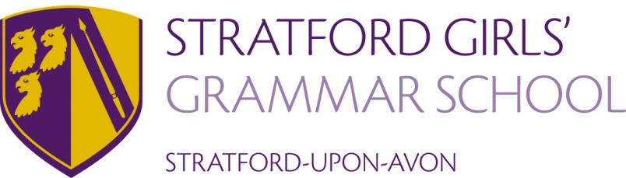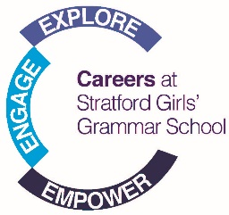

SGGS Careers Programme
Aims - The SGGS Careers Programme aims to foster the skills that are necessary for students to be successful in the world of work as well as enabling students to access information about specific career paths and employment opportunities.
The Careers Programme at SGGS is designed to follow the Gatsby Benchmarks – a framework of 8 guidelines that define the best careers provision in schools and colleges:
Benchmark | Description
1. A stable careers programme | Every school should have an embedded programme of career education and guidance that is known and understood by pupils, parents, teachers and employers.
2. Learning from career and labour market information | Every pupil, and their parents, should have access to good-quality information about future study options and labour market opportunities.
3. Addressing the needs of each pupil | Pupils have different career guidance needs at different stages. Opportunities for advice and support need to be tailored to the needs of each pupil. A school’s careers programme should embed equality and diversity considerations throughout.
4. Linking curriculum learning to careers | All teachers should link curriculum learning with careers. For example, STEM subject teachers should highlight the relevance of STEM subjects for a wide range of future career paths.
5. Encounters with employers and employees | Every pupil should have multiple opportunities to learn from employers about work, employment and the skills that are valued in the workplace. This can be through a range of enrichment activities including visiting speakers, mentoring and enterprise schemes.
6. Experiences of workplaces | Every pupil should have first-hand experiences of the workplace through work visits, work shadowing and/or work experience to help their exploration of career opportunities, and expand their networks.
7. Encounters with further and higher education | All pupils should understand the full range of learning opportunities that are available to them. This includes both academic and vocational routes and learning in schools, colleges, universities and in the workplace.
8. Personal guidance | Every pupil should have opportunities for guidance interviews with a careers adviser. These should be available whenever significant study or career choices are being made. They should be expected for all pupils but should be timed to meet their individual needs.

The Careers Programme inevitably has an element of variation year on year but always includes a number of key elements e.g. assemblies from external speakers; the Sixth Form Speaker program; work experience and the sharing of information and guidance via PSHE lessons and events such as Careers Fairs.
There are “one off” events that also occur from time to time (often they are linked to external funding or unique opportunities).
Year 7 | PSHE lessons cover a range of Careers related topics (as part of a wider curriculum) including “What are skills?”, “Why do employers want you to have “skills”?”, “How can you develop your skills?”  Students complete a “My Career Action Plan” which focuses on goals and achievements.  The focus in Year 7 is broad and encourages students to learn about their interests and strengths rather than a narrow focus on specific career areas.
Year 8 | The PSHE programme builds on Year 7 work and includes research into employment law, what a CV is and how people apply for jobs.
Year 9 | Students research routes into specific careers that interest them.  The PSHE programme continues to build on previous years by looking at body language and interviews.  Options Assembly in December begins the options process. Presentation for parents and students at the Year 9 Progress Evening and a booklet detailing options.  Students take part in the National Enterprise Challenge in March as part of National Careers Week.
Year 10 | “What Career Live” Careers and University Fair at the NEC  PSHE programme uses Unifrog to explore pathways such as university and apprenticeships
Year 11 | PSHE programme includes Unifrog to look at themes such as CV writing and interview skills  Future’s Week in the autumn term focuses on post 16 pathways and particularly on A-Level subject choices.  All students have a 1:1 Careers Guidance appointment with our qualified Careers Adviser as well as 1:1 transition conversations to prepare for entry to sixth form  Work experience post GCSE exams
Year 12 | Around 25% of Year 12 students undertake a weekly work experience placement  All Year 12 undertake a week’s work experience placement in July.  Higher Education Evening is run by the Head of Sixth Form in April.  Individual support from the Careers Adviser and/or Head of Sixth for UCAS application process and post 18 pathways, including extra support for early applicants to medicine, veterinary and dental courses and Oxbridge.  Sixth Form Speaker Program  Young Enterprise competition and Business and Engineering option offered via Stretch and Challenge  1:1 Careers Guidance Interviews accessible through Careers Office
Year 13 | Mock interviews  Individual support from Careers adviser/Head of Sixth for managing UCAS offers  1:1 Careers Guidance Interviews accessible through Careers Office
All / multiple year groups | Biennial Careers Fair March – Year 9 and up.  National Careers Week - e magazine to parents, staff and girls daily. Outside speakers throughout the week from a range of employment areas.  Individual 1:1 careers guidance is available through the Careers Office.  Independent careers advice is also accessible via our e-mags and other useful links which are on the Careers page of our website.  Students are registered with Unifrog in Year 9 which is available to them until they are 25 and aims to support progression through the GCSE, post 16 and post 18 pathway. Unifrog helps to give the students specific individual feedback regarding career areas that may be suitable for them or of interest. It also provides labour market information and links this to academic subject areas.

