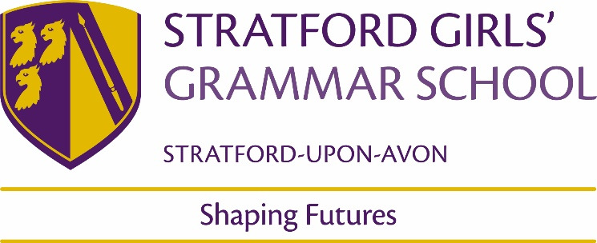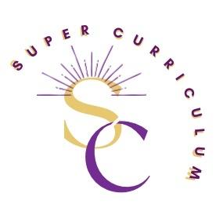

KS5 Politics Department
Super Curriculum
Reading (books and journals)
Title by Authors Name
British Politics a very short introduction by Tony Wright – an excellent starting place  Democracy a very short introduction by Bernard Crick – Another excellent short précis of how democracy developed  The Communist Manifesto – Karl Marx. Excellent, short introduction to Politics, Economics and Revolution. Read Das Kapital if you have a spare week or two.  Why Marx was Right by Terry Eagleton – A controversial argument but an engaging one  The Social Contract by Jean Jacques Rousseau – A great read with some great ideas  Butler to the world by Oliver Bullogh – A sad inditement of what Britain has become post Empire and how we got there  Ill fares the land by Tony Judt – A great argument to those who say we need to keep society the way it is. | Behold America by Sarah Churchwell – An in-depth analysis of the History of Trump’s America First maxim  On Tyranny: 20 lessons from the 2oth Century by Timothy Snyder – short, incisive and powerful  We were eight years in power by Ta-Nehisi Coates – A collection of essays written over the course of the Obama period  Mistaken Identity: race and class in the age of Trump by Asad Haider – as it says in the title  Collusion by Luke Harding – What is the relationship between Russia and Trump? Find out here  The Fifth Risk by Michael Lewis – An outline of how Trump didn’t seem to care about government when he became president, but actually more about the amazing people who make up the US bureaucracy  National populism: The revolt against Liberal Democracy by Roger Eatwell and Matthew Goodwin – What is populism and why is it happening?  How Democracies die by Steven Levitsky and Daniel Ziblatt – self-explanatory really
Podcasts / Films
Podcasts:  New York Times https://www.nytimes.com/spotlight/podcasts  Mother Jones https://www.motherjones.com/podcasts/ https://www.liberaloasis.com/  https://www.thenation.com/  https://www.bbc.co.uk/news/world/us_and_canada for an American perspective  The Rest is Politics https://open.spotify.com/show/1Ysx8g1Iw42gESAtegrFaH The New Statesman podcast  https://www.newstatesman.com/podcasts  Unprecedented  https://www.globalplayer.com/podcasts/42Kub5/  Pod Save the UK  https://crooked.com/podcast-series/pod-save-the-uk/  The audio long read  https://www.theguardian.com/news/series/the-audio-long-read  Five Thirty Eight Politics  https://fivethirtyeight.com/tag/politics-podcast/  Pod Save America  https://crooked.com/podcast-series/pod-save-america/  Wilderness podcast  https://crooked.com/podcast-series/the-wilderness/  Remainiacs  http://www.remainiacs.com/  Call your Girlfriend  https://www.callyourgirlfriend.com/episodes  Still Processing  https://www.nytimes.com/column/still-processing-podcast  Political Gabfest  https://slate.com/podcasts/political-gabfest  Newscast  https://www.bbc.co.uk/sounds/brand/p05299nl | Films/ TV:  The West Wing – Any of the series you can get your hands on, ideal for showing the inner workings of US government, remember it is an idealised Liberal view; presidents are not like this really.  The Wire (Particularly series 1 to get used to the language and series 3 focusing on the education system). Real life cult viewing showing how political decisions have an effect on everyday life. Strong violence and language so be warned, and you will get hooked.  The Daily Show with Trevor Noah showing on Comedy Central presently, daily satirical show very good for examples to use in interview. There is an excellent App you can download as well.  The Thick of it – More up to date satire on the Blair / Brown years of government, see also the film “In the Loop”, be warned very strong language.  Have I got News for you?  Mock the week  Who is America  The Handmaids tale is back on C4 watch season 1+2  Question Time  The politics show – useful for examples and an understanding of Westminster  The Now Show on Radio 4 can be downloaded as podcast – very funny political sketch show
Films:  Knock down the house  Get me roger stone  Citizenfour, Prime Video  Fahrenheit 9/11  Inside job  The edge of democracy  Citizen koch  Capitalism a love story,  Sicko,  The corporation  RBG | Blade Runner  The Matrix trilogy  Groundhog day  A Clockwork Orange  I Daniel Blake  The Post  Argo  Frost Nixon  All the Presidents men  Team America: World Police  Good night and good luck  Selma  Land and Freedom  Zero dark Thirty  Election  In the loop  The Battle for Algiers
MOOCs and on-line opportunities
https://www.open.edu/openlearn/society/free-courses Society, Politics & Law  Sciences Po - FUN MOOC (fun-mooc.fr)  https://www.coursera.org/learn/inequality-and-democracy (Utrecht University)  https://www.coursera.org/learn/global-diplomacy-un (Utrecht University) | https://www.coursera.org/learn/geopolitics-europe (Sciences Po)  The Supreme Court & American Politics | edX  (University of Baltimore)  https://www.edx.org/xseries/harvardx-us-government? (Harvard University – an introduction to American Government & Politics)  Politics: An Introduction (Online) | Oxford University Department for Continuing Education  (Oxford University, an online introduction to politics)  Diversity & Inclusion Courses - FutureLearn - FutureLearn
Awards and competitions
Holodomor essay prize  Robinson college, Cambridge essay prize  Girton college, Cambridge humanities essay prize  John Locke institute essay prize  LSE undergraduate political review essay competition  R.A.Butler prize Trinity College Cambridge | https://www.augb.co.uk/holodomor/holodomor-essay-prize-2023  https://www.robinson.cam.ac.uk/prospective-students/essay-prize  https://www.girton.cam.ac.uk/humanities-writing-competition  https://www.johnlockeinstitute.com/essay-competition  https://blogs.lse.ac.uk/lseupr/2022/09/13/lseupr-school-essay-competition-2022/  https://www.trin.cam.ac.uk/undergraduate/essay-prizes/politics/
Places to visit
People’s History Museum
International Slavery Museum
Black cultural archives
Queer Britain Museum
Black Country Living Museum
Hay Festival
Membership and affiliations
Political Studies Association | https://www.psa.ac.uk/

