SUPERCURRICULUM |  |  | ART KS4  Extending your learning beyond the curriculum  SHAPE GROW GUIDE SUCCEED  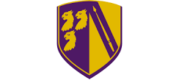

OUR SUPPERCURRICULUM
At SGGS we believe that Art has the capacity to make connections with ALL other subjects in our curriculum, thus deepening and enhancing your understanding of a particular theme. To achieve this and encourage you to become strong, independent learners, we have designed a Supercurriculum with creativity, independence and curiousity – all are key skills which are highly valued and transferrable.

The Supercurriculum can teach you about:

- encouraging independent thought and decision making
- use of resources and ‘thinking outside of the box’
- helps your teachers determine your understanding, strengths and interests
- presentation skills

So what is the Super curriculum?

It is designed to take the subjects you study in the classroom beyond that which your teacher has taught you or what you’ve engaged with for home learning. A Supercurriculum enables you to go into an area in more depth or to learn about
a new area of your subject entirely.

These activities can take the form of reading, watching programmes or videos, listening to podcasts, lectures, engaging in practical activities to visiting museums and galleries or entering competitions.

Engaging in super curricular activities will help you develop a love for your favourite subject or subjects. In this brochure the Art Department have suggested some starting points but we encourage you to share your own ideas and recommendations with us, so that our Supercurriculum can grow and be shaped by you.

Don’t forget that this style of independent learning and research will be of interest to further education unis and future employers, so consider including your findings in your future applications.

Enjoy the Supercurriculum and don’t forget to share your findings with us!

J Hillier
Head of Art, T&L Lead

TRANSFERRABLE SKILLS
Transferable skills are skills that you take with you through life, from one job to another. Examples of transferrable skills include the ability to take calculated risks, to effectively communicate ideas to others, handle and solve unexpected problems, or working well as part of a team.

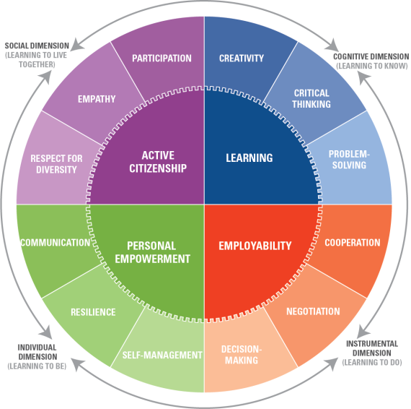

reading / RESEARCH | 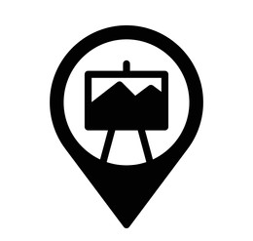  Visit museum/gallery | leadership | listening
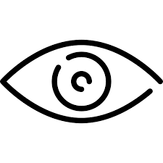  watch | 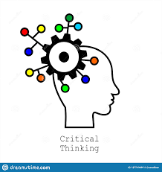  critical thinking | creative task | writing

Have a go at a life drawing class, either locally on online such as through the Royal Academy of Art. | Teach yourself advanced  techniques using  Photoshop | Source a local artist whose style of work interests you. Use Warwickshire Open Studios as a guide. Ask them if you can interview them about their practice and work. Write the interview up in a journalist style and submit it to the Art Department for publication.
Elaboration - Develop your knowledge by teaching yourself more about an art technique and then teach it to somebody else. | Start a creative travel journal which accompanies you everywhere. Have a look at this link for inspiration:  https://www.youtube.com/watch?v=eahtnxsg2GE  https://www.youtube.com/watch?v=a-iZcweTvLU | Increase your artist knowledge by watching interviews or listening to talks https://www.tate.org.uk/art/videos
Research and find some art classes, either in person or online. | Read Art magazines. There’s a pile in F4 just waiting to be borrowed, read and returned! | Go to an Art exhibition.  Tips: London galleries and museums, Birmingham ICON, Birmingham Museum and Art Gallery, Modern Art Oxford, Ashmolean, Compton Verney.
Ask big questions and find the answers, such as: What’s the earliest form of Art that has been found in the world? | Get crafty. Teach yourself how to knit, crochet or embroider. | Investigate the different forms of art, craft and design from different cultures around the globe. What’s the most interesting one to you and why?
Which 5 fashion designers are making the biggest impact in terms of sustainable fashion? | Explore the work of 10 Textile Artists and explore their different techniques:  https://www.wallpaper.com/art/contemporary-textile-artists  https://www.textileartist.org/10-contemporary-embroidery-artists | Read a novel about art or artists. Here are some that the RA recommend but doing your own research or asking our library team for assistance is even better!  https://www.royalacademy.org.uk/article/10-novels-about-art
Watch an Art Film or expand your knowledge with documentaries. Here are some suggestions:  https://www.royalacademy.org.uk/article/10-artist-movies-and-documentaries-to-watch-on-netflix-amazon-iplayer  https://www.ica.art/films  https://www.sky.com/watch/channel/sky-arts  You could even write a review afterwards and share it with the Art Department | Where can Art take you? Watch this short video from Tate Shots and pay attention to the different creative careers the presenters have.  https://www.youtube.com/watch?v=vKjkx6PzajE  Can you do your own research into creative careers? What is the most interesting career to you? Or perhaps the most bizarre? | Buy a small  sketchbook and challenge yourself to draw as  much as possible from  observation. Aim to make a  drawing/sketch/painting/collage  every day for two weeks. This  could be a quick 5 minute study to  one hour. Show your art teacher  your art work once you have  finished!
Enter an Art, Design, Craft, Photography, Sculpture Competition.  Keep your eye out for competitions posted on the Whole School TEAMS channel or do your own research into what’s out there. | Drawing people is a difficult skill. The best way to improve in this area is simply to practice. create a few drawings of friends and family members. Try to work from life rather than a picture, this is much harder but will help to improve your observational skills.  To help and inspire you, have a look at the work by artist Dryden Goodwin and watch his technique as he draws portraits of London Underground tube workers:  https://art.tfl.gov.uk/projects/linear/ | Listen to some arty podcasts. Research your own or start with some of these links to get you going:  https://www.royalacademy.org.uk/article/9-art-podcasts-to-help-you-pass-the-time-in-lockdown  https://podcasts.ox.ac.uk/series/history-art-special-lectures-and-research-seminars
Become a  Young Arts Leader. Present your thoughts on the GCSE Art course during a lunchtime session to younger learners and show your sketchbook. Answer any questions they may have. | GCSE Bitesize Art and Design  https://www.amazon.co.uk/Bitesize-design-Complete-Revision-Practice/dp/1406654361/ref=sr_1_1?s=books&ie=UTF8&qid=1500456626&sr=1-1&keywords=gcse+bitesize+art | Teach yourself how to make a camera obsura or research, make and explore your own photography with a pin hole camera.

