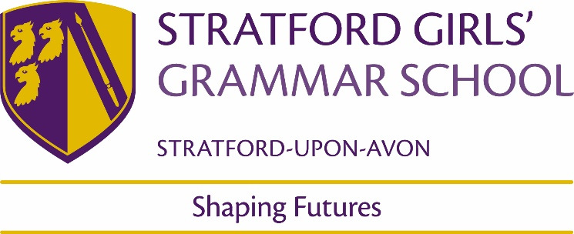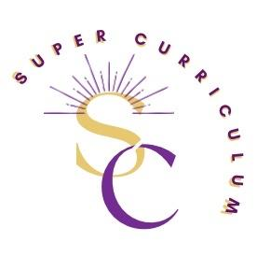
Chemistry Department
Super Curriculum
Reading (books and journals)
Reading list | Books  The Science Magpie, Simon Flynn  A Bee in a Cathedral, Joel Levy  The Disappearing Spoon and Other Extraordinary True Tales from the Periodic Table, Sam Kean  Reactions: The Private Life of Atoms, Peter Atkins  Bad Science, Ben Goldacre  The Fontana History of Chemistry, William Brock  Periodic Tales: The Curious Lives of the Elements, Hugh Aldersley-Williams  Molecules: A Very Short Introduction, Philip Ball  Molecules at an Exhibition (The Science of Everyday Life), John Emsley  The New Chemistry, Nina Hall  Nature’s Building Blocks: An A-Z Guide to the Elements, John Emsley  Why Chemical Reactions Happen, James Keeler and Peter Wothers  A Short History of Nearly Everything, Bill Bryson  How to Fossilise Your Hamster, Mick O’Hare  The Periodic Table, Primo Levi  Magazines/Journals  New Scientist, New Scientist | Science news, articles, and features  Catalyst magazine, Catalyst Magazine - Issue 43 (catalyst-magazine.org)  Chemistry Review, Chemistry Review - Hodder Education Magazines  Chemistry World, Chemistry news, research and opinions | Chemistry World
Chemistry newsletter/ displays/Molecule of the month | Up-to-date Chemistry news/discoveries/etc. Quirky facts about everyday molecules. See Whole School Team for updates
Openlearn | Discovering chemistry - OpenLearn - Open University  Metals in medicine - OpenLearn - Open University  The science of alcohol - OpenLearn - Open University
Podcasts
TED talks/BBC radio/RSC | Imperial College Online Lectures https://www.imperial.ac.uk/be-inspired/social-and-multimedia/lectures-online  Chemistry TED talks https://www.ted.com/talks?topics%5B%5D=chemistry  In Our Time, Chemical Elements (BBC) BBC Radio 4 - In Our Time, Chemical Elements  Brought to you by Chemistry (RSC) http://www.rsc.org/periodic-table/podcast  The Infinite Monkey Cage (BBC) BBC Radio 4 - The Infinite Monkey Cage
Documentaries | Behind the curve (Netflix)  Pain, Pus and Poison: The Search for Modern Medicines (BBC)  Secrets of the Super elements (BBC)  Chemistry: A volatile history (BBC)  H2O: The Molecule that Made Us (BBC)
MOOCs and on-line opportunities
MOOC | Exploring Everyday Chemistry, York University/Future Learn  The Trillionth Tonne of Carbon and Why It Matters For Climate Change | Gresham College  Microbial Master-Chemists | Gresham College
Awards and competitions
Olympiad (KS5) | https://edu.rsc.org/enrichment/uk-chemistry-olympiad
Cambridge Challenge (KS5) | https://www.c3l6.com/about
Pending Top of the Bench (KS4), Salters challenge (KS3), RSC Analysts competition (KS5) | Practical Chemistry competitions  https://edu.rsc.org/enrichment/top-of-the-bench  https://festivalsofchemistry.org/  https://edu.rsc.org/enrichment/schools-analyst
Chemistry quiz (KS3) | Multiple choice themed Chemistry quizzes are posted fortnightly on TEAMs
Pending Online Chemistry competition (KS4) | National Scientific Thinking Challenge (warwick.ac.uk)
Places to visit
Warwick University (KS5) | Chemistry in Action lectures Chemistry in Action - Education in Action
Membership and affiliations
RSC | https://www.rsc.org/ Royal Society of Chemistry

