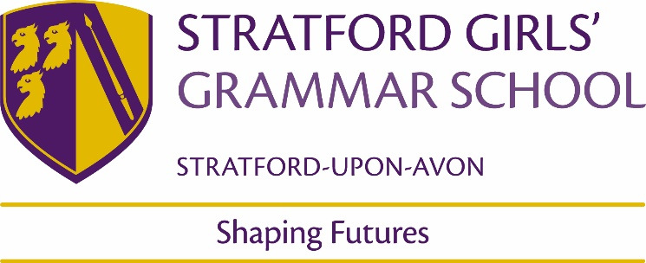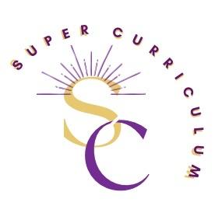

KS3 History Department
Super Curriculum
Reading (books and journals)
Title by Authors Name
The Eagle of the Ninth by Rosemary Sutcliffe
A traveller in time by Alison Uttley
The Silver Sword by Ian Serraillier
The Tudor Court series of 6 books by Phillipa Gregory
The Galleons’ grave (book 1 of the Henry Gresham series) by Martin Stephen
The book smugglers of Timbuktu by Charlie English
Black and British: A short essential History by David Olusoga
The book thief by Markus Zusak
The Mill Children by Suzanne Marshall
Sally Heathcote: Suffragette by Mary Talbot and Kate Charlesworth

Podcasts / Films
Podcasts:  1066 and all that  https://soundcloud.com/englishheritage/episode-130-1066-and-all-that-the-events-and-people-behind-the-battle-of-hastings  Rest is History  https://open.spotify.com/show/7Cvsbcjhtur7nplC148TWy  BBC – In our time  https://www.bbc.co.uk/programmes/b006qykl/episodes/downloads  PAX Britannica  https://paxbritannica.info/  Revolutions  https://open.spotify.com/show/05lvdf9T77KE6y4gyMGEsD  1619  https://www.nytimes.com/2020/01/23/podcasts/1619-podcast.html  Witness History  https://www.bbc.co.uk/programmes/p004t1hd/episodes/downloads  Dan Snow’s History Hit  https://www.historyhit.com/podcasts/  The memory palace  https://thememorypalace.us/ | Films:  Elizabeth  Mary Queen of Scots  Cromwell  Amistad  12 Years a slave  Peterloo  Days of Hope  1917  Suffragette  The Pianist  Oppenheimer  Dunkirk  All the Presidents men  Frida  Hidden Figures  Made in Dagenham  Pride
MOOCs and on-line opportunities
www.historylearningsite.co.uk
www.schoolhistory.co.uk
www.spartacus-educational.com
Awards and competitions
Places to visit
Black Country Living Museum
International Slavery Museum
British Museum
People’s History Museum
Soho House Museum
Blakesley Hall
Membership and affiliations
Historical Association | https://www.history.org.uk/

