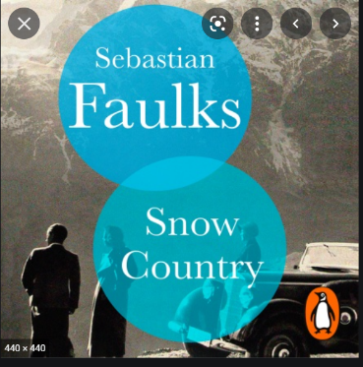
Sixth Form A-Level English Literature Students Enjoyed an Evening with ‘Birdsong’ author Sebastian Faulks

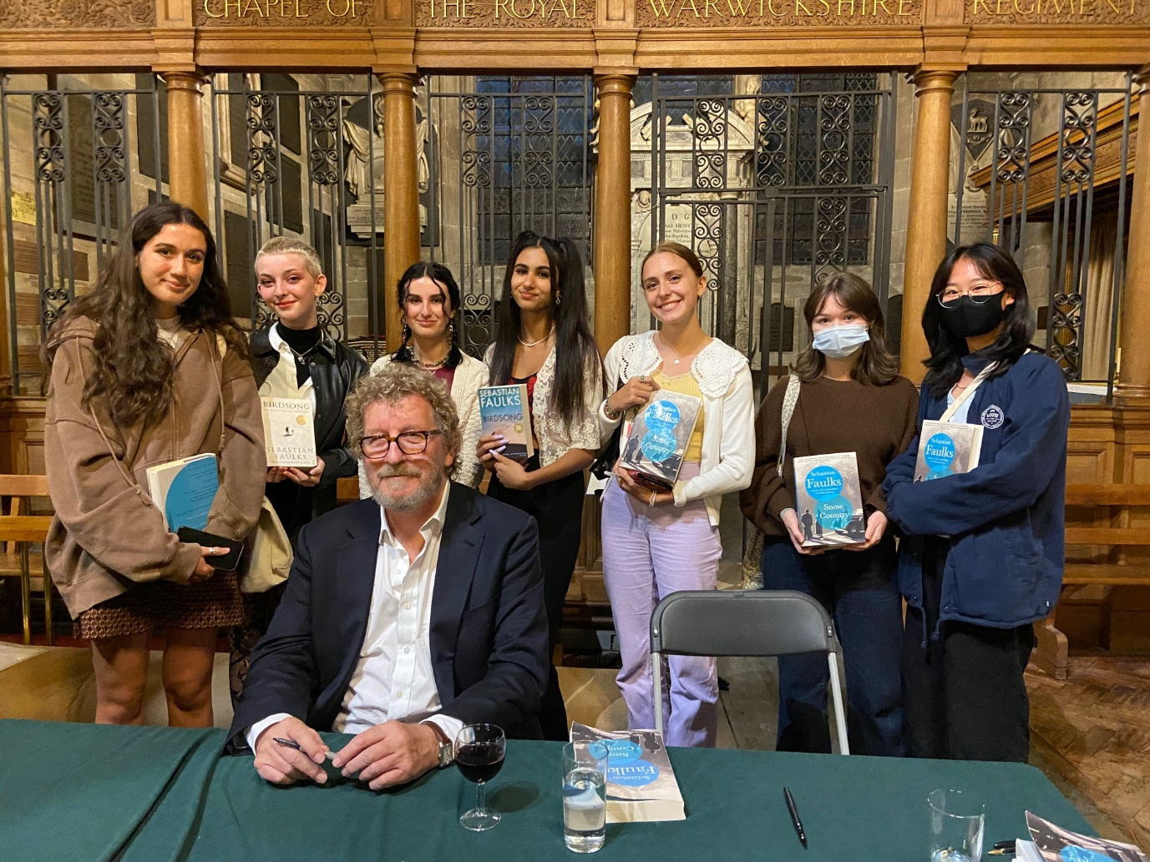

Year 12 and 13 A-level English Literature students travelled to St Mary’s Church, Warwick on Saturday September 11th to enjoy an evening with acclaimed author Sebastian Faulks.
As part of the Edexcel A-level English Literature course students explore Faulks’s multi-million best seller novel ‘Birdsong’ so it was an apposite treat for us to be able to hear him discuss his most recent work ‘Snow Country’. Faulks spoke about the influences on his writing. He was questioned about his repeated use of the war to explore humanity to which he replied that by using enormous transitional world events such as WWI he is able to expose the ways that mankind responds both physically and psychologically to adversity.
Faulks took questions from the audience after his hour-long discussion (interviewed by local author Kit de Waal whose best selling novel My Name is Leon is soon to be dramatized by the BBC).

